**METAPHORUM CONFERNECE 2016**

**Governance and Complexity**



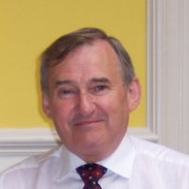

**Prof Peter Allen**

**Professor Peter Allen** is an Emeritus Professor at the Cranfield Management School, and was previously Head of the Complex Systems Research Centre, School of Management, Cranfield University. He is an Invited Professor in economics at the University of Paris I, as well as contributing to Masters and Doctoral programmes at Warwick and Aston Business Schools. He is Editor in Chief of the journal *Emergence: Complexity and Organization.* He is currently engaged in a large ESRC research project using complexity science to understand the evolution of the supply chain of aerospace companies.

**His research applies the new ideas concerning evolutionary complex systems to socio-economic sustainability, resilience and security.**





**Dr David Benjamin**

**Dr David Benjamin** is a principal at Syntegrity Group, overseeing all of the organization’s delivery of Syntegrations and other social technologies. He also acts as an advisor to executives from Fortune 500 (and larger) organizations across North America and the world.



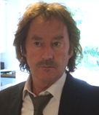

**Dr Stephen J. Brewis**

**Dr Stephen J. Brewis** began his professional career as a Marine Engineer in the Merchant Navy, later left to join the NHS, and now works at BT, where he came to research organisational complexity and the challenges it poses. It is in this area that he met the late Stafford Beer, and was fortunate to work with him in his later years. Stephen co-founded SCiO, and has continued to advance thinking in organisational cybernetics. Stephen’s current challenge is improving the Adaptive Response of BT through the transformative fusion of cybernetics, systems dynamics, social capital and Biological Stigmergy facilitating the creation of conversational white spaces.



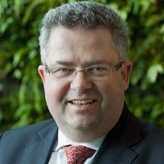

**Dr Olaf Brugman**

**Dr Olaf Brugman** is manager for sustainability policies and dialogue at Rabobank, and the president of the Roundtable for Responsible Soy (RTRS). He holds a doctorate in business studies from Radboud University Nijmegen and an MA in public administration from Twente University.

He first got to know the Viable System Model of Stafford Beer in 1985, and has applied and studied management cybernetics throughout his professional activities. Recently, he initiated a team Syntegration event to make soy supply chains more sustainable, in partnership with RTRS and the Malik Institute.



[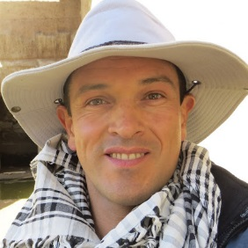](https://www.google.co.uk/url?sa=i&rct=j&q=&esrc=s&source=images&cd=&cad=rja&uact=8&ved=0ahUKEwjs7f2L547PAhUJPhQKHfuxDFEQjRwIBw&url=https://plus.google.com/114616666092985955746&psig=AFQjCNHV9WBuoFdlxFf1atykSkrQffmIXA&ust=1473940672917849)

**Dr Pedro Pablo Cardoso Castro**

**Dr Pedro Pablo Cardoso Castro** is a Senior Lecturer at Leeds Beckett University. Originally a marine biologist and Colombian Merchant Marine officer, after several years of research in this field he moved into environmental management, international commerce, and from there into strategy more generally, obtaining a PhD on complexity management and self-organization. His research focuses on sustainability, governance, Higher Education and social enterprise, and throughout applies the principles of complexity management and the theory of viability.





**Russell Clemens**

**Russell Clemens** is a principal policy officer at the building commission of the State Government of Western Australia and his work is informed by his current role. In recent years he has been working on the diagnostic of the 'cultural feasibility' (or otherwise) of systemically desirable change and viable outcomes while pursuing sustainability goals through management cybernetics (Beer), ecology of mind (Bateson), biology of cognition (Maturana) and soft systems methodologies (Checkland).



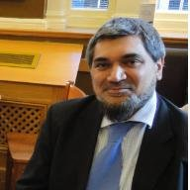

**Dr Aftab Dean**

**Dr Aftab Dean** is the Deputy Director of the DBA programme at Leeds Beckett University. He developed the first MSc in E-business for the HE sector and remains active in the digital marketing field, maintaining a close rapport with digital companies. His research interests include social responsibility, governance, branding and student engagement; his consultancy work includes designing data collection instruments and mining complex databases to inform new strategies for innovation and growth. He has designed and delivered a range of workshops looking at a range of approaches and analytical techniques including factor analysis, cluster analysis, regression, decision tree, GLM modelling and polytomous logistic regression.



[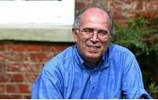](http://www.google.co.uk/url?sa=i&rct=j&q=&esrc=s&source=images&cd=&cad=rja&uact=8&ved=0ahUKEwjB2r3hgI_PAhVIL8AKHU50D4kQjRwIBA&url=http://socialsciencecentre.org.uk/blog/2016/01/12/social-cybernetics-and-the-social-science-centre-lincoln/&psig=AFQjCNFfdsuklBTyXV8l3qGTpe_CSm7ECw&ust=1473947581770712)

**Prof Raul Espejo**

**Professor Raul Espejo** is the head of Syncho Ltd, a consulting firm in the field of organizational cybernetics, a visiting professor at the University of Worcester, and the Director General of the World Organisation of Systems and Cybernetics. He worked as a systems engineer before going into research; since then, his and Syncho’s work has focused on the design of organizations with the support of information technology and communications; and on problems of transparency in decision-making. He has taught courses, seminars and conferences in more than 20 countries in Europe, the Americas and Asia.



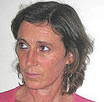

**Dr Angela Espinosa**

**Dr Angela Espinosa** is a Reader at the University of Hull and an Invited Fellow at the Universidad de los Andes in Colombia. She worked in various information systems roles in public and private enterprises, including the Colombian President’s Office, before gaining her PhD.

She has led projects involving the restructuring of national auditing practices, the application of systems tools to national educational and environmental policies, and participation in political systems. In the last decade, she has focused her research on complexity and sustainability, specifically on self-organisation in SMEs, eco-communities and networks.



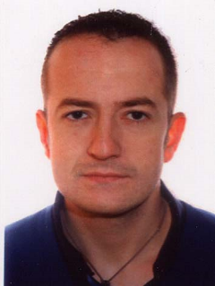

**Carlos Failde Juiz**

**Carlos Failde Juiz** is an industrial engineer by training, and part of the Organization Development Department at Financiera Maderera S.A. During his time at the company he previously worked in production and in the Continuous Improvement Team. He first encountered Stafford Beer’s model upon joining his current department in 2013.



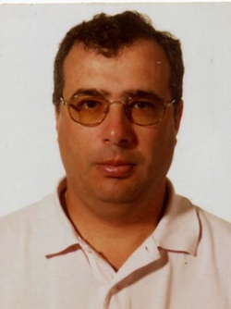

**Constante Fontan Pol**

**Constante Fontan Pol** is part of the Organization Development Department at Financiera Maderera S.A. In his 35 years at the company he has previously worked in production, quality, logistics, and the Continuous Improvement Team. He holds a degree in Chemistry from Universidad de Santiago de Compostela.



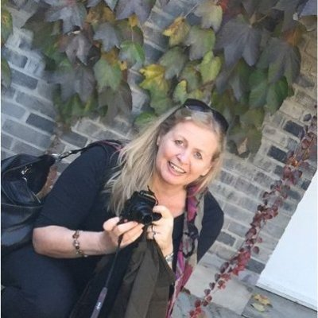

**Gabriele Harrer**

**Gabriele Harrer** is an expert management consultant dealing with complex systems in multiple contexts and sectors. Her main areas of expertise is on the application of the Sensitivity Model for systems modelling, development of scenarios, and transparent simulation in managerial and public projects.

She lectures at the Armed Forces University in Munich, the University for International Business Management in Ravensburg Weingarten, and is a Visiting Professor at Capital University of Economy and Business in Beijing.



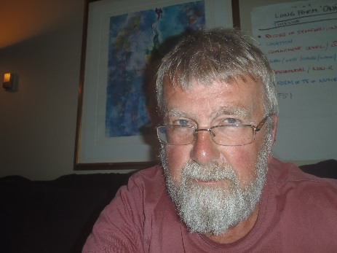

**Dr Roger Harnden**

**Roger Harnden** completed his PhD on the ways in which the insights of autopoiesis and structural determinism impact upon our understanding of human understanding in the age of the Internet. He worked with Stafford Beer on the early development of Team Syntegration, was a co-founder of Amaze Ltd, and worked with Roy Stringer on models for the design of hypermedia data structures suitable for a connected global world. On leaving Amaze, formed Nascent Form Ltd; since closing down Nascent Form in 2010, he has been primarily interested in understanding the implications of the work of Humberto Maturana.



**Paul Hayes**

**Paul Hayes** is the Corporate Policy Manager at Wakefield Council, which has had a Memorandum of Understanding with Leeds Beckett University for several years relating to business and enterprise education. His role involves evaluation of national and regional policy on behalf of the Council and advising senior political and managerial decision makers on impacts and opportunities from national and regional policy agendas and emerging social, economic and demographic trends for the district and sub-region.

Paul is presently studying for his PhD at Leeds Beckett, looking at the impact of devolution of funding and powers on innovation and economic productivity in the North.



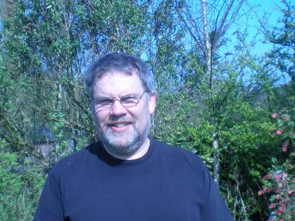

**Martin Holt**

**Martin Holt** began work in a tannery as a coatings technologist and production manager. He then worked for the Ministry of Defence as a quality manager & management tutor, ending up as the Head of Organisational Development for a large Defence Agency; then as the Head of Public Sector Excellence at the Cabinet Office, followed by a senior position with the General Medical Council. He now combines tutoring in management & technology for a number of Universities with consultancy & providing specialist advice to a medical regulator. He has taught undergraduate & postgraduate systems modules at the Open University for nearly 25 years.



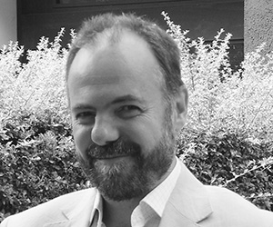

**Patrick Hoverstadt**

**Patrick Hoverstadt** ran an engineering business for 13 years before becoming a consultant, which he has now done for more than two decades. He has worked with organizations across the public and private sector on issues to do with organizational and structural change, and specialises in using systems approaches for analysing and designing organizations and work processes. He is the author of *Fractal Organization* published by Wiley in 2008 and co-author of *Patterns of Strategy*, published by Gower in 2016. He chairs SCiO, a group of systems practitioners, and is a Fellow at Cranfield School of Management.





**Mark Johnson**

**Mark Johnson** is concerned with applying cybernetic techniques, software development and philosophy to education and technology. He works as an educational technologist at Liverpool University within the Faculty of Health and Life Sciences, and is involved in projects on Patient Safety and Organisational Risk, and the treatment of diabetes. Each of these presents problems of human organisation where technological interventions create new possibilities for coordination. In the past he has led EU and JISC projects in educational technology, focussing on the technological potential for enhancing personalised learning.





**Dr Markus Junginger**

**Dr Markus Junginger** is Associate Partner at MHP (A Porsche Company), providing expert advice to firms on how to prevail in uncertain and complex environments. He has experience as Executive Vice-president at Alexander Proudfoot and as lead Partner at Gallup. Markus has degrees in Operations Research and Engineering and a PhD in Capital Market Theory, focusing on bounded rationality and decision making. His book on Wargaming is an application of behavioral game theory on strategic decision making and simulation in a corporate context. He lectures at two German universities and is a member of the New England Complex Systems Institute.



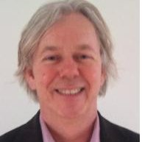

**Dr Jan Kuiper**

**Dr Jan Kuiper** studied Sociological Economics at Rijks Universiteit, Groningen. He has since worked as a policy advisor and consultant in both the public and private sectors, and is the co-founded if IcoDrome, a leading Dutch company in the field of Syntegration and Management Cybernetics.

Jan’s research focuses on strategic management, socio-systemics and cybernetics, and coaching and training.



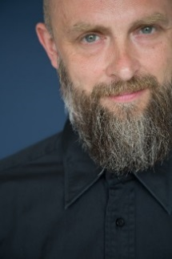

**Dr Mark Lambertz**

**Dr Mark Lambertz** is the author of the first German introduction to the Viable System Model, “Freedom and Responsibility for Intelligent Organizations” (March 2016). In 1995 he co-founded, and for 20 years ran, one of the first digital agencies in Germany called anyMOTION. Today he helps companies to discover and implement their potential as a Viable System in the digital age. He offers a unique mixture of profound digital expertise and systemic thinking. He is a member of the Bertalanffy Center for the Studies for Systems Science and lectures on Corporate Governance and Project Management at Mediadesign Hochschule für Design und Informatik, in Düsseldorf.



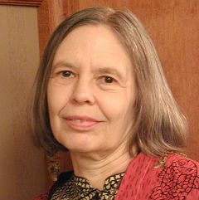

**Dr Allenna Leonard**

**Dr Allenna Leonard** is an American cyberneticist, consultant, and Director of Team Syntegrity Inc, based in Toronto and specialising in the application of Stafford Beer’s Viable System Model and Syntegration.

Allenna is committed to continuing to use and publicise Beer’s work, with a special interest in using Syntegration as a forum for democratic dialogue, especially on issues of public important. She is especially interested in accountability measures that address multiple perspectives, including organizational adaptation and environmental criteria.



**Huw Lloyd**

**Huw Lloyd** has worked on software development practice and the processes of learning and collaboration for more than twenty years. His current research focuses on Cultural-Historical Activity Theory, particularly in relation to the science of education and psychological development, and on programming.



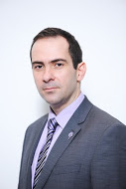

**Dr George Lodorfos**

**George Lodorfos** is the Dean of Leeds Business School. He has extensive practical and academic experience in the fields of Strategic Management, R&D and Adoption of New Technologies and Innovation. Dr Lodorfos's research interests are in the broad thematic areas of Innovation, Enterprise and Change and Consumer Behaviour. Particular research themes include: organisational changes in the form of mergers, acquisitions, demergers and divestments; management of R&D in technology intensive industries; the factorsthat enable SMEs' sustainable development; and on how to "boost" business growth for enterprises.



**Carolina Malagón Robayo**

**Carolina Malagón Robayo** trained in accountancy, specialising in financial management, and then gained her MBA from Universidad de los Andes in Colombia. She is now studying for her doctorate at Universidad del Rosario in Bogotá.

Carolina has consulted for both public and private organisations on costing system implementation, strategic management, organizational management and the implementation of International Financial Reporting Standards (IFRS.) She has taught and researched management, finance and financial accounting at several Colombian universities.





**Penny Marrington**

**Penny Marrington** is a management consultant with more than 18 years of experience in the use of complexity and cybernetics. She is currently the CEO of Sigma Two Ltd and has academic experience from her former role as a senior lecturer at the Open University.



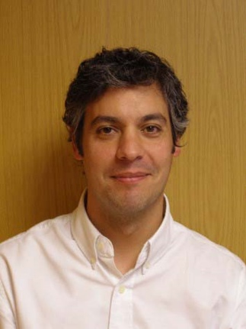

**Alejandro Miguez Viqueira**

**Alejandro Miguez Viqueira** holds a degree in psychology from Universidad de Santiago de Compostela and has worked at Financiera Maderera S.A. since 1998. He has held a variety of senior posts in HR and is now a Business Partner for the Finance and IT areas, as well as participating in global projects.



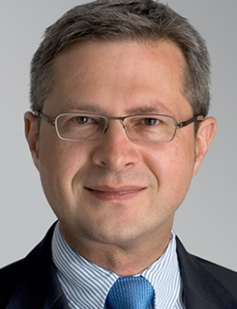

**Dr Martin Pfiffner**

**Dr Martin Pfiffner** studied economics at the University of St Gallen, and studied Management Cybernetics under Prof Stafford Beer and Prof Fredmund Malik. He is an expert in Syntegration, organizational structure, effective leadership, system-oriented management, strategy, and management cybernetics, with more than 20 years of experience as an expert consultant in these areas.

He is a partner and member of the board of directors at Malik Management Zentrum in Switzerland.



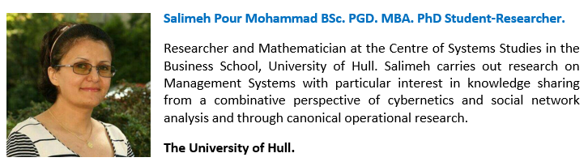

**Salimeh Pour Mohammad**

**Salimeh Pour Mohammad** is a researcher and mathematician at the Centre for Systems Studies at the University of Hull. She carries out research on management systems with a particular interest in knowledge sharing, from a combinative perspective of cybernetics and social network analysis and through canonical operational research. She is currently studying for her PhD.



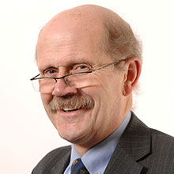

**Prof Simon Robinson**

**Reverend Professor Simon Robinson** is Professor of Applied and Professional Ethics at Leeds Beckett University, having formerly been a university chaplain at several institutions. His research is focused on ethics in higher education, leadership, governance, integrity, and he has a particular interest in Islamic thinking on ethics, especially in the work of Fethullah Gülen. He is director of the Research Centre for Governance, Leadership and Global Responsibility, chief editor of the new Palgrave book series on Governance, Leadership and Responsibility, and editor of the *Journal of Global Responsibility*.



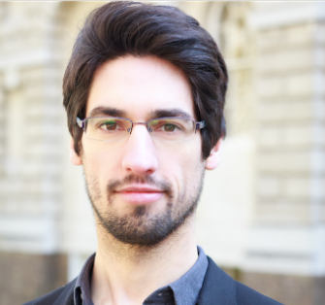

**Nuno Rosa**

**Nuno Rosa** has recently completed a MSc in Technology Management at UCL and is working towards the International Diploma in Business Analysis awarded by the British Computer Society. He is interested in understanding the systemic nature of organisations and businesses and how they can be improved.



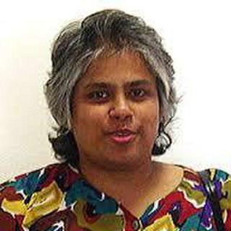

**Dr Leonie Solomons**

**Dr Leoni Solomons** is committed to building ‘process’ infrastructure in her native country, Sri Lanka. This includes building Optical Character Recognition (OCR) technology for the Sinhala and Tamil languages; conducting Study Skills workshops in vernacular languages so that children using them can be introduced to Systems Thinking; and evaluating proposed national policy using VSM.

Dr Solomons’ corporate experience is in the banking-computing sector and ranges from Strategic Planner to Project Management for the Commonwealth Bank of Australia and EDS Australia. Todayshe primarily works with her team at Language Matters in Sri Lanka.





**Dr Ralf-Eckhard Türke**

**Dr Ralf-Eckhard Türke** is the Managing Director for the Competence Center at the Institute for Systemic Management and Public Governance in St Gallen. Ralf has experience as CEO of different organizations such as Sustainance GmbH; TheHub and TheHub Zurich, and as project manager at Malik Management Zentrum in St. Gallen.



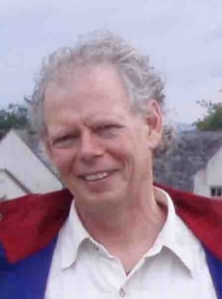

**Dr Jon Walker**

**Dr Jon Walker** holds a PhD in Cybernetics, and has over thirty years’ experience working in the co-operative business sector. He has established and co-managed a range of businesses including retail outlets, a small-scale manufacturing plant, a warehouse and a chain of supermarkets. He continues to have direct involvement with the co-operative food sector in Yorkshire; nationally, he is working with the Transition Network, the Permaculture Association and the Cooperative Group. Jon has lectured, published, consulted and provided training courses in both private and public sectors, on organisational structures both nationally and internationally.



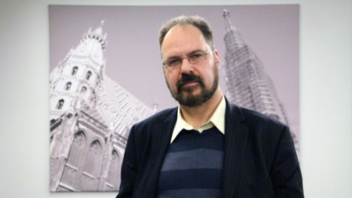

**Dr Steve Wright**

**Dr Steve Wright** is a Reader in Applied Global Ethics at Leeds Beckett University. He has also worked with NGOs such as Amnesty International, Human Rights Watch, Privacy International, Pugwash, HURIDOCS, Statewatch and the Mines Advisory Group, as well as the European Parliament and Commission.

His work on torture, surveillance, small arms and new police technologies has led to awareness-raising and policy changes around the world. His most recent EC work has been concerned with reviewing the way we assess the ethics and societal impacts of security technologies.

